

**Dhol Pathak**

# A REPORT ON WEB TECHNOLOGY

# (SEMESTER VI)

*Submitted by*

**31124 Harsh Dhawale**

**31137 Vinayak Jamadar**

**31138 Sanket Jhavar**

# THIRD YEAR ENGINEERING

**Society for Computer Technology and Research’s**

**PUNE INSTITUTE OF COMPUTER TECHNOLOGY**

**DHANKAWADI, PUNE – 43**

# A.Y. 2022-23

-**CERTIFICATE-**

This is to certify that the work incorporated in the report entitled **“Dhol Pathak,”** is carried out by

**31124 Harsh Dhawale**

**31137 Vinayak Jamadar**

**31138 Sanket Jhavar**

who is part a group of students under the subject ***Web Technology*** during A.Y.**2022-2023.** Such material has not been submitted to any other University/ Institute for any financial support. The literature related to the problem investigated has been appropriately cited and duly acknowledged wherever facilities and suggestions have been availed of.

**Date: 17/05/2023**

**Place: PUNE**

**Name & Sign of WT lab teachers**

**Prof. P. T. Kohok**

# ABSTRACT

The Dhol Pathak Website is an innovative online platform designed to enhance the experience of both Dhol Pathak teams and customers seeking to book their services for various programs and events. This abstract provides an overview of the website's key features and benefits, emphasizing its user-friendly interface, team registration capabilities, and convenient booking system.

The website serves as a centralized hub, connecting Dhol Pathak teams and potential customers in a streamlined manner. Dhol Pathak teams can create their profiles, showcasing their skills, experience, and repertoire. This platform offers an opportunity for teams to gain visibility, expand their reach, and connect with a broader audience.

# ACKNOWLEDGEMENT

On behalf of the entire group entitled with Group , we are obliged to thank our prestigious institute, SCTR’S PUNE INSTITUTE OF TECHNOLOGY, our principal Dr.R. Sreemathy for offering us such opportunity. Next, we would like to give our gratitude for our project’s guide, caretaker and advisor Prof. P. T. Kohok ma’am for their timely efforts and share of experience, which contributed to completion of this project. A special thanks goes to our peers and teaching staff for guiding and encouraging us throughout this journey. We also thank our teammates for their immense contribution and research which was put in for the development of this project.

# TABLE OF CONTENT

|  |  |  |
| --- | --- | --- |
| **CH. NO.** | **TITLE** | **PAGE NO.** |
| 1 | INTRODUCTION | 6 |
| 2 | OVERALL DESCRIPTION | 10 |
| 3 | FLOWCHARTS | 14 |
| 4 | IMPLEMENTATION DETAILS | 15 |
| 5 | CONCLUSION | 19 |

**LIST OF FIGURES**

|  |  |  |
| --- | --- | --- |
| **FIGURE NO.** | **TITLE** | **PAGE NO.** |
| 1 | HOMEPAGE | 17 |
| 2 | LOGIN PAGE | 17 |
| 3 | SIGN UP PAGE | 17 |
| 4 | LANDING PAGE | 18 |
| 5 | MY LISTINGS G PAGE | 18 |

**CHAPTER 1**

# INTRODUCTION

* **MOTIVATION**
* Streamlining the Booking Process: The traditional process of booking Dhol Pathak teams for events and programs can often be time-consuming and inefficient. By introducing a dedicated booking platform, the aim is to simplify and streamline the process, making it easier for customers to find and book their preferred Dhol Pathak teams quickly and conveniently.
* Enhancing Accessibility and Visibility: Many talented Dhol Pathak teams may struggle to gain exposure and reach potential customers beyond their immediate networks. The booking platform aims to address this challenge by providing a centralized online space where teams can create profiles, showcase their skills, and gain visibility among a wider audience. This increased accessibility can lead to more opportunities for teams to showcase their talent and secure bookings.
* Empowering Dhol Pathak Teams: The platform's primary focus is to empower Dhol Pathak teams by providing them with a dedicated space to promote their services. By allowing teams to create detailed profiles, share performance videos, and receive reviews and ratings, the platform enables teams to highlight their unique qualities, establish their reputation, and attract more customers. This motivation encourages teams to strive for excellence and continuously improve their performances.
* Facilitating Informed Decision-Making: Customers seeking Dhol Pathak teams for their events or programs often face challenges in assessing the quality, availability, and suitability of different teams. The booking platform addresses this issue by providing comprehensive information about each team, including performance videos, customer reviews, and availability calendars. This enables customers to make informed decisions based on their specific requirements and preferences.

# OBJECTIVE/PURPOSE

The purpose of the Dhol Pathak Booking Platform is to provide a centralized and efficient online platform that connects Dhol Pathak teams with customers seeking their services. The platform aims to streamline the booking process, empower Dhol Pathak teams, enhance accessibility, and promote the traditional art form of Dhol Pathak.

We have identified several key purposes that drive our project:

1. Simplify the Booking Process: The platform aims to simplify and streamline the process of booking Dhol Pathak teams for events and programs. By providing an easy-to-use interface and comprehensive team information, customers can quickly find and book their preferred teams, saving time and effort.
2. Enhance Visibility for Dhol Pathak Teams: The platform seeks to enhance the visibility of Dhol Pathak teams beyond their immediate networks. By creating detailed team profiles, showcasing performance videos, and enabling customer reviews, the platform aims to increase exposure and opportunities for teams to attract a wider audience and secure more bookings.
3. Facilitate Informed Decision-Making: The platform aims to provide customers with the necessary information to make informed decisions when selecting Dhol Pathak teams. By offering comprehensive team profiles, performance videos, and customer reviews, customers can evaluate and compare teams based on their specific requirements and preferences.
4. Promote Traditional Art and Cultural Heritage: The platform aims to promote the traditional art form of Dhol Pathak and its cultural significance. By providing a dedicated space for Dhol Pathak teams, the platform helps preserve and promote this vibrant aspect of Indian culture, ensuring its continued recognition and appreciation.
5. Embrace Technology for Efficiency: The platform leverages technology to create a more efficient and convenient booking process. By harnessing the power of online platforms, the objective is to eliminate unnecessary manual processes, such as phone calls and in-person meetings, and enable bookings to be made seamlessly anytime, anywhere.

# SCOPE OF THE PROJECT

The scope of the Dhol Pathak Booking Platform encompasses various aspects related to connecting Dhol Pathak teams and customers, facilitating the booking process, and promoting the traditional art form. The following elements define the scope of the platform:

**CHAPTER 2**

# OVERALL DECRIPTION

* + **FUNCTIONAL REQUIREMENTS**

1. User Registration and Authentication: The platform should provide a user registration system that allows both Dhol Pathak teams and customers to create accounts. Users should be able to authenticate themselves securely to access the platform's features.
2. Dhol Pathak Team Registration and Profile Creation: Dhol Pathak teams should have the ability to register themselves on the platform and create their profiles. This includes providing information such as team name, contact details, performance videos, repertoire, pricing, availability, and any other relevant details.
3. Customer Panel: The platform should have an Customer panel to manage user accounts, team profiles, bookings, reviews, and other platform-related settings. The admin panel should provide sufficient control and functionality to ensure smooth platform operations.
4. Mobile Compatibility: The platform should be designed to be responsive and mobile-friendly, allowing users to access and use its features seamlessly on different devices, including smartphones and tablets.

# NON-FUNCTIONAL REQUIREMENTS

1. Performance: The website should have fast response times and be able to handle a large number of concurrent users without significant delays or performance degradation.
2. Scalability: The website should be scalable, capable of accommodating increasing numbers of users, reported items, and system activity without compromising performance.
3. Reliability: The website should be reliable and available for use consistently, with minimal downtime or disruptions. It should have backup and recovery mechanisms in place to ensure data integrity and system stability.
4. Security: The website should prioritize security measures to protect user data, prevent unauthorized access, and safeguard against potential threats such as hacking or data breaches. This can include encryption, secure authentication, and adherence to privacy regulations.
5. Usability: The website should have a user-friendly interface, making it easy for users to navigate, report lost or found items, and search for matches. Clear and intuitive design elements, such as wel-organized menus and search filters, contribute to a positive user experience.
6. Accessibility: The website should be accessible to users with disabilities, conforming to accessibility standards and guidelines to ensure equal access to al individuals.
7. Compatibility: The website should be compatible with various web browsers, operating systems, and devices to ensure a seamless user experience across different platforms.
8. Data Management: The website should efficiently handle and manage data, ensuring data integrity, accuracy, and compliance with data protection regulations. It should have appropriate data storage and backup mechanisms in place.
9. Performance Monitoring and Analytics: The website should incorporate monitoring tools to track system performance, identify bottlenecks or issues, and gather analytics to gain insights into user behavior and system usage.
10. Documentation and Help Resources: The website should provide clear and comprehensive documentation, including user guides and FAQs, to assist users in navigating the platform and understanding its features.

# OPERATING ENVIRONMENT

* + - Database:
  1. MongoDB
     + Software Requirements:

1. VS Code Editor
2. NodeJS framework
3. ExpressJS framework
4. Programming Languages Used:
   1. JAVA SCRIPT
      * Hardware Requirements:
5. Minimum Core i5 Processor
6. Windows 10/11th Gen
7. Minimum 8 GB RAM
8. Minimum 256 GB SSD

**CHAPTER 3**

# FLOWCHARTS

* **FLOWCHART**

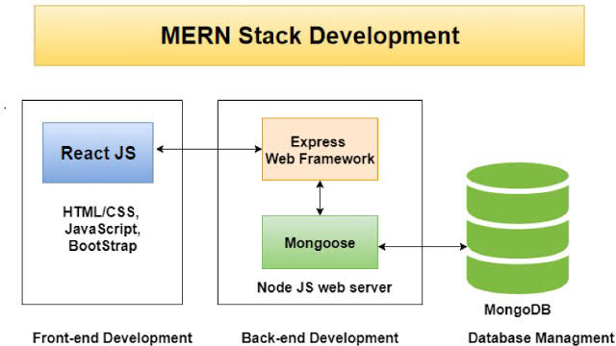

**CHAPTER 4**

# IMPLEMENTATION DETAILS

The implementation of our project, Dhol Pathak” involved the utilization of various technologies and frameworks to create a functional and efficient online auction platform for used electronic items. Here are the key implementation details:

1. Frontend Development:
   * ReactJS: ReactJS is a popular JavaScript library for building user interfaces. It was developed by Facebook and released in 2013. React alows developers to build reusable UI components that can efficiently update and render data as it changes.
   * Tailwind CSS: The frontend UI was designed and styled using Tailwind CSS, a utility-first CSS framework. Tailwind CSS alowed for rapid UI development by providing a comprehensive set of pre-defined utility classes.
2. Backend Development:
   * NodeJS: Node.js is a JavaScript runtime built on Chrome's V8 JavaScript engine. It alows developers to run JavaScript on the server-side, enabling them to build scalable and high-performance web applications
   * ExpressJS: Express.js is a framework that sits on top of Node.js and provides a layer of abstraction to simplify web development. It handles common web development tasks, such as routing, request handling, and middleware management, alowing developers to focus on building the actual application logic.
   * MongoDB: MongoDB is a popular NoSQL database that provides a flexible and scalable solution for storing and managing data. It differs from traditional relational databases by using a document-oriented model instead of tables with rows and columns.
3. User Authentication and Authorization:
   * Token-based authentication was implemented using JSON Web Tokens (JWT) to authorize API requests and protect sensitive endpoints.
4. Testing and Quality Assurance:
   * Comprehensive testing methodologies, including unit tests and integration tests, were employed to ensure the stability and reliability of the system. Continuous integration and continuous deployment (CI/CD) pipelines were set up to automate testing and deployment processes.
5. Documentation and Reporting:
   * + Detailed documentation was prepared, covering system architecture, instal ation instructions, and user guides. This documentation provided comprehensive information for developers and end-users to understand and utilize the platform effectively.

By implementing these technologies and following best practices in software development, we successfuly built and deployed the "Dhol Pathak" online searching platform for lost items. The implementation process focused on creating a user-friendly interface, robust backend functionality, and real-time data features to enhance the overal user experience.

# SCREENSHOTS

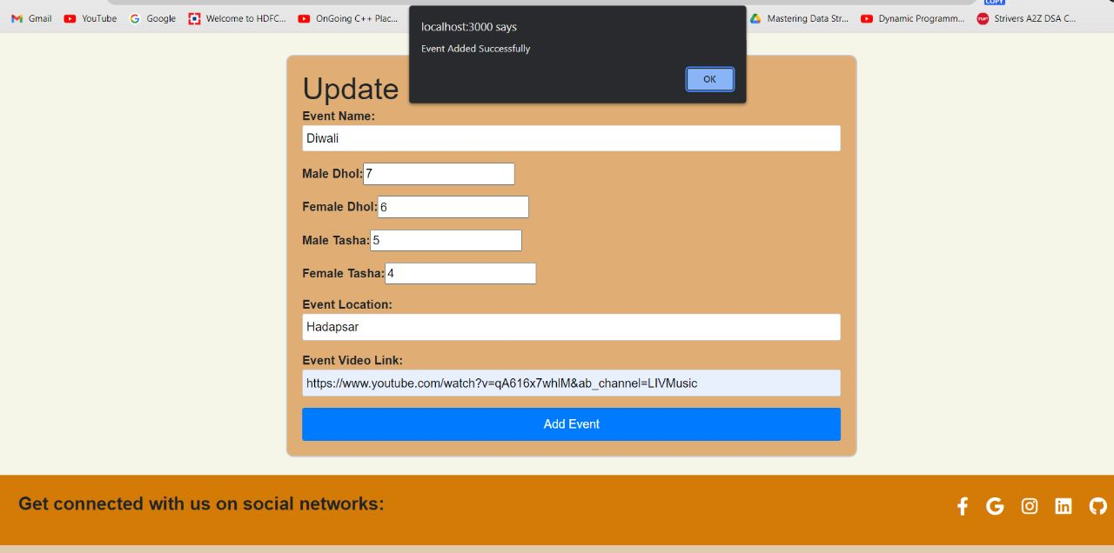

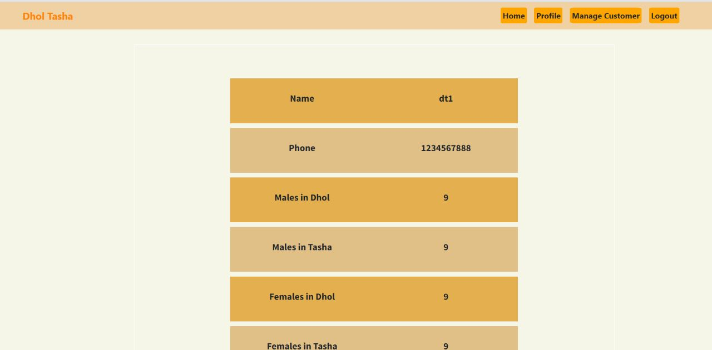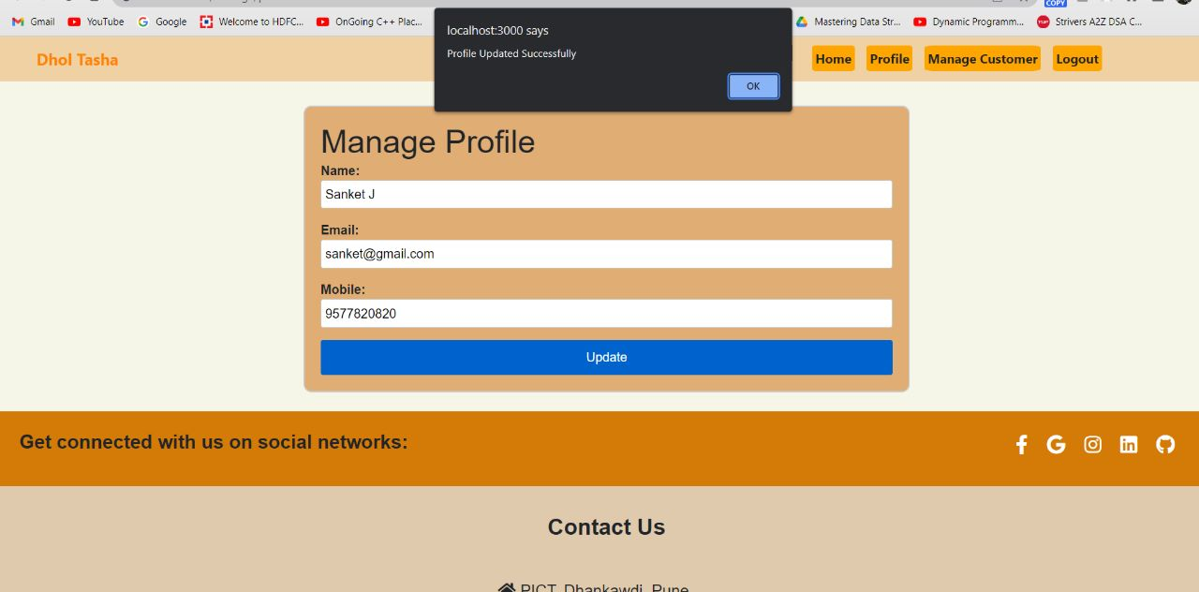

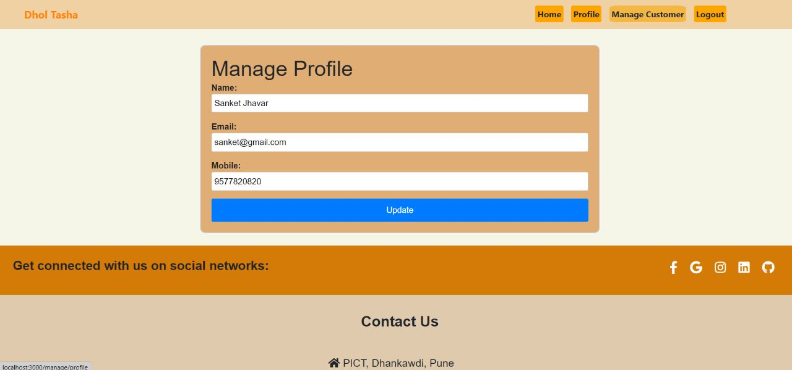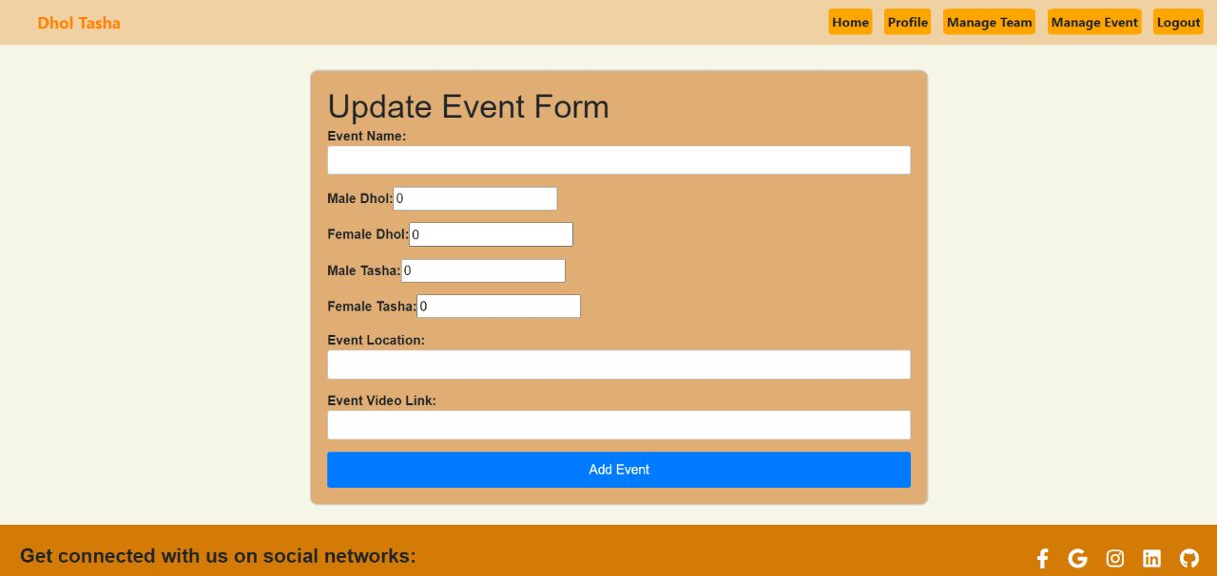

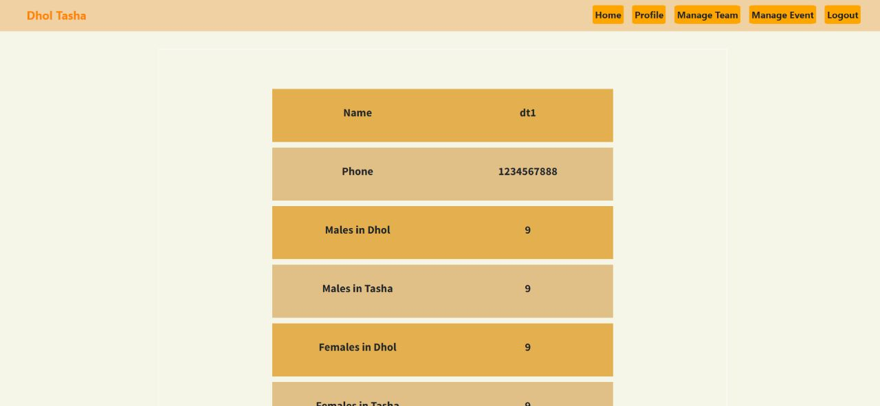

**CHAPTER 5**

# CONCLUSION

In conclusion, the Dhol Pathak Booking Platform serves as a centralized and efficient online solution that connects Dhol Tasha teams with customers seeking their services. The platform aims to simplify the booking process, empower teams, enhance accessibility, and promote the traditional art form of Dhol Tasha.

By providing a user-friendly interface, team registration capabilities, and a convenient booking system, the platform streamlines the process for customers to find and book their preferred Dhol Tasha teams. Customers can explore team profiles, evaluate performances through videos and reviews, and make informed decisions based on their specific requirements and preferences.

# FUTURE SCOPE

The Dhol Pathak Booking Platform has a promising future with potential for growth and expansion. Here are some of the key areas of future scope for the platform:

* + - Geographic Expansion: Currently, the platform may focus on specific regions or cities. However, there is an opportunity to expand its reach to cover a wider geographic area, allowing Dhol Tasha teams and customers from different locations to connect and benefit from the platform's services.
    - Integration of Additional Services: The platform can explore the integration of additional services related to Dhol Tasha performances, such as costume rentals, sound system arrangements, event management services, or collaborations with other cultural performers. This expansion can provide a comprehensive and convenient experience for customers, offering them a one-stop solution for their event requirements.
    - Collaboration with Event Organizers: The platform can collaborate with event organizers to offer seamless integration with their event management systems. This can simplify the process for organizers to book Dhol Tasha teams through the platform, further enhancing the platform's visibility and reach.
    - Customization and Personalization: Providing customization options for customers, such as the ability to request specific songs or choreography, can enhance the platform's appeal. Teams can have the opportunity to showcase their adaptability and cater to the unique preferences of customers, creating a more personalized experience.
    - Additional Booking Features: The platform can consider incorporating advanced features such as real-time availability updates, instant booking confirmation, and flexible rescheduling options. These features can further streamline the booking process, improving convenience for both teams and customers.